**Lesson 03 Demo 03**

**Designing User Interfaces with Generative AI**



Steps to be followed:

1. Create a user interface for the product page

**Step 1: Create a user interface for the product page**

1. Navigate to the website **https://uizard.io/** and click **Sign up free** to create a designing account

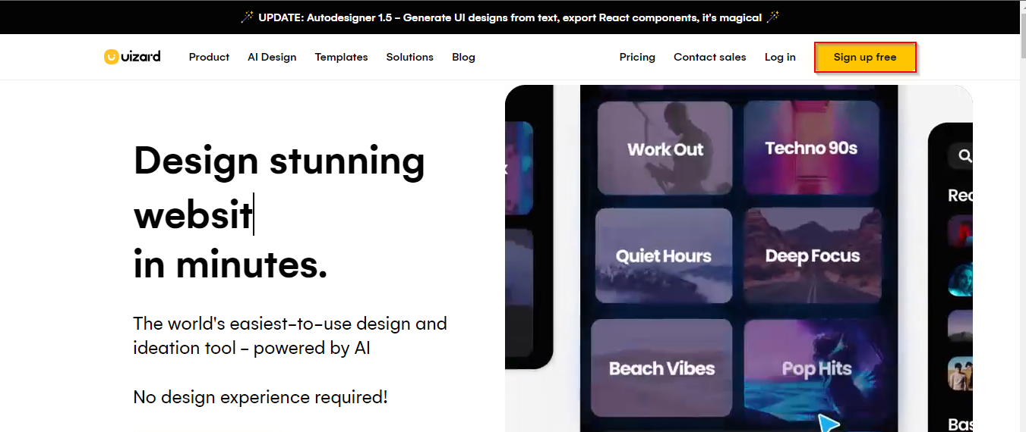

1. Enter your **First name**, **Last name**, **Work Email**, and **Password**. Now, click **Create account.**

1. Select **New blank project**, and click on **Web** to create a new blank project

1. Clickon **Screen**, and click **Generate screen** to get a new home screen to design the project

1. Click **Prompt** to generate a prompt

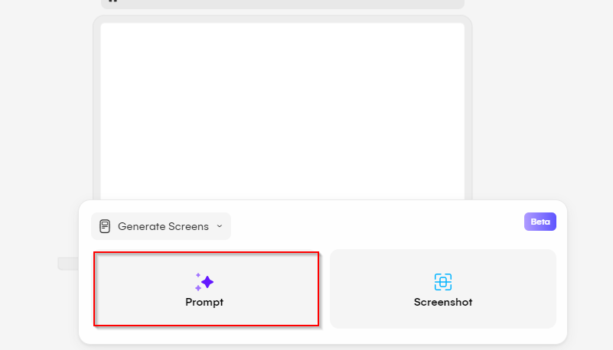

1. Use the following prompt to create an e-commerce product page:

**An E-commerce product showcase page**

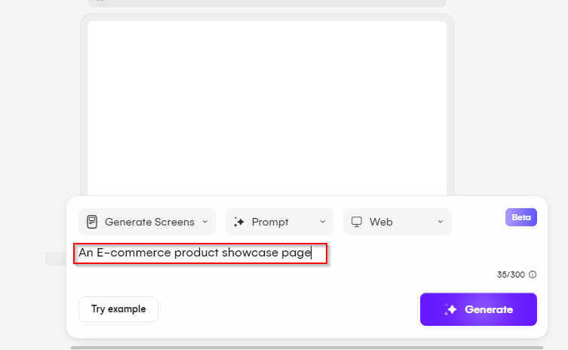

1. Select any page and click on it

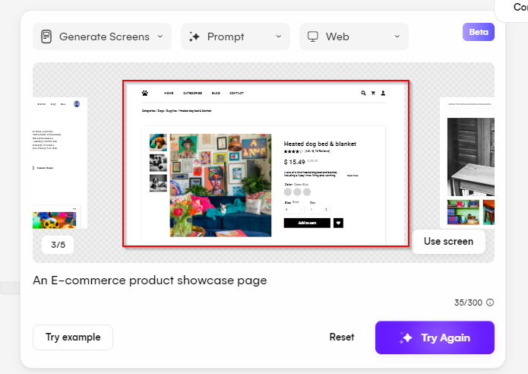

1. The AI-generated page is successfully created. You can click on **Share**, **Export**, or **Preview** from the tab as shown below:

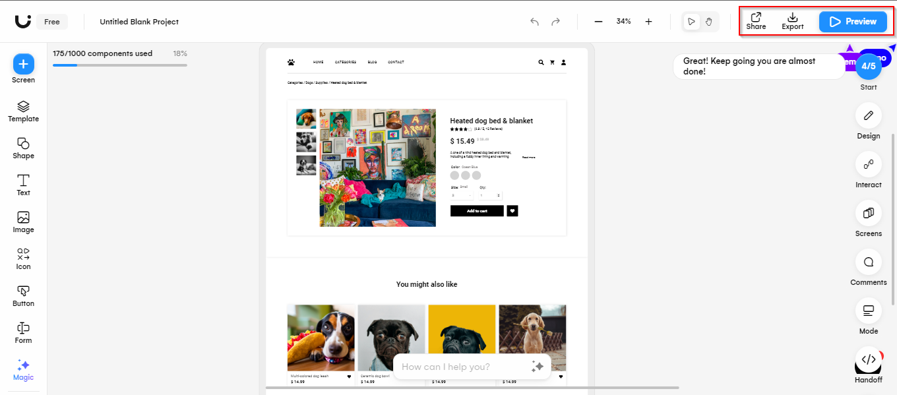

1. Click **Screen**, and click on **Wireframe** to upload hand-drawn sketches

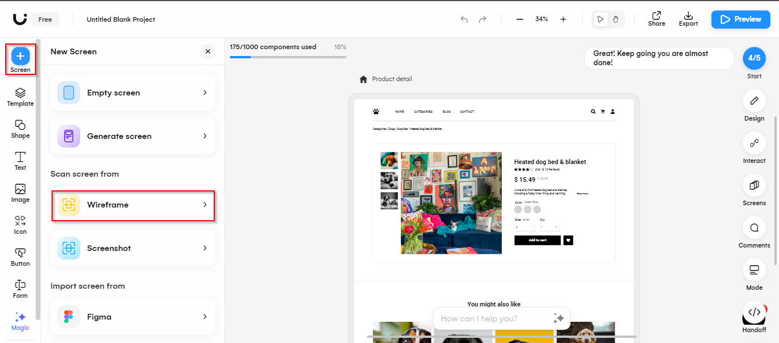

1. Click **Import**

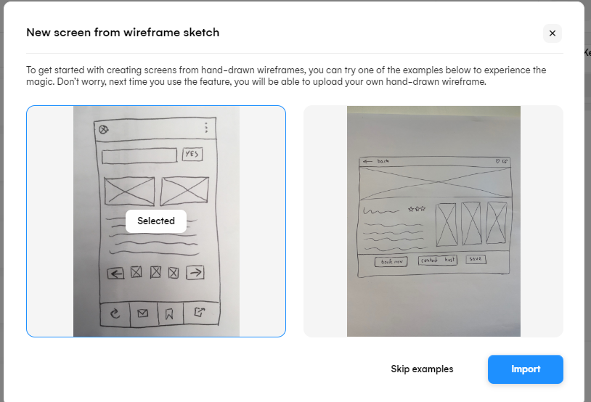

1. Click **Add to cart**, and click on **Suggest** to get design change suggestions

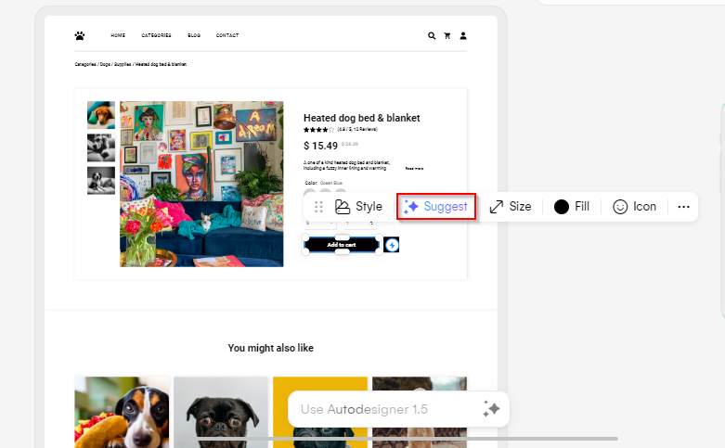

1. Click on the **Generate** button

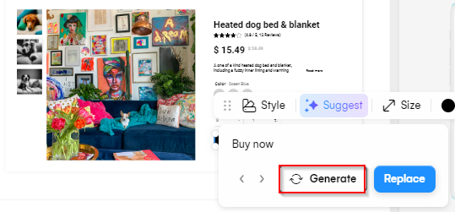

1. Select any suggested change and click on the **Replace** button

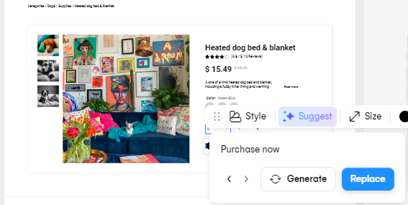

By following these steps, you have successfully created an e-commerce product showcase page using Generative AI.